APPLICATION FOR FUNDING
The Westerville Education Challenge

Date of Application: July 19, 2013
Name and Classification of Project leader: Kyle Campbell, ecology and zoology teacher at WNHS
Names of others involved: Brooke Cochran AP biology WNHS, Lyndsey Manzo AP environmental science WNHS
Home Address of Project Leader: 807 Keyham Terrace Dr. Westerville, OH 43082
Home Phone: 614-794-0707 School Phone: 614-282-9271
Email address: campbelk@wcsoh.org or mr4dude@gmail.com
Name of School: Westerville North High School
School Address: 907 County Line Rd. Westerville, OH 43081
Grade Levels: 11, 12 and all

Title: CONSERVATION, and the PRESERVATION OF BIODIVERSITY at THE WNHS LAND LAB
Funding Requsted Amount $ 3, 523.51
OVERVIEW
This is an all inclusive grant that will benefit WNHS, Heritage Middle School, Robert Frost Elementary, and any other classrooms in the Westerville City Schhols system that would like to participate. Multiple grades, classes, ages, and disciplines will be invited to study, record, observe, and experiment in this multi-annual comprehensive study of game fish, turtle populations, nesting sites, and habitat requirements of the organisms that inhabit the land lab pond facility. This grant is devoted to the conservation, preservation,and restoration of pond game fish, and the resurrection of a once depleted reptile and amphibian population. The goal of this grant is estimate population numbers and physical sizes of game fish, turtles, frogs, and salamanders to maintain or increase healthy populations so the biodiversity of the pond can be kept in check by biological and non- harmful synthetic structures, nor chemicals which will also enhance the beauty of the entire facility. The new building is a wonderful addition to our district, but some ongoing projects and equipment are necessary to maintain a strong outdoor education center that can involve the entire district. Westerville North High School has partnered with elementary schools in the past for sustainable science day, the rain garden planting, and the Robert Frost enrichment cluster pond study program. Being awarded with the title” A State Wild School Site” by the Ohio Division of Wildlife makes the land lab an even more special place to bring classes. With these grant dollars being approved, it is our hope that more schools, grades, and classrooms will be involved in hands on, real science, outdoor education.
OBJECTIVES
#1. GET AN ACCURATE POPULATION COUNT OF MAJOR ORGANISMS LIVING IN AND AROUND THE POND
One of the main jobs of an Ecologist, biologist, or naturalist is to understand the types of organisms and their numbers that live in a specific area. This information is valuable in assessing nutrient acquisition like cycles (carbon, nitrogen, water), food chains, webs, and pyramids, and predator – prey interactions. Normally, if a population is declining then there is a limiting factor involved. Our goal is to maintain stable populations and keep a balance of factors that support them. Knowing the species and numbers of them that exist can help us understand how we can help perpetuate the biodiversity of all species that should be inhabiting our land lab ecosystem.
SOLUTION: High school students in ecology, zoology, A.P. biology, and A.P. environmental science will participate in a population study of aquatic plants, algae, zooplankton, macroinvertebrates, game fish (largemouth bass, bluegill, pumpkin seeds, and green eared sunfish), turtles ( red eared sliders, painted , and snapping ), frogs (leopard, green, and bullfrog), and salamanders (spotted and cricket).
METHODOLOGY: Students from the high school will partner with middle and elementary school students for 2 days in the Fall to catch fish, tag them, then releasethem, only to catch them again one week later in a capture/recapture technique called the Lincoln Index (P1XP2 / r =N (number of species). This technique is flawless given the large capture and recapture numbers that can be achieved by this collaborative experiment between all three grade levels. Fish are tagged in the dorsal fin by fish taggers bought from Forestry Suppliers. The forty fishing poles will be Zebco push button casting reels from Amazon.com.
Turtles will be captured in a Pond King foating turtle trap that ensures their safety. They will be marked by a file on the back of their shell.
Frogs will be captured in pre-existing nets, identified, sexed, weighed, then released. They will not be marked, but will be quantified and still is good representative data of the Lincoln Index.

#2 IMPROVE THE BIODIVERSITY AND INCREASE THE NUMBERS AND PHYSICAL SIZE OF THE GAME FISH INHABITING THE POND
Due to the amount of invasive plant species, especially American Water Lotus which was introduced in 1982, the land lab pond bottom has become basically a thick, muddy, bottom substrate of decayed plants. This soft, fine mud is extermely insufficient and not the primary surface to lay eggs on by bass, bluegill, sunfish, and pumpkinseeds, the primary game fish in the pond. A more course substance like sand and gravel is the most preferred spawning beds for these gamefish.
Another problem is when a small percentage of the eggs hatch, then there are not many hiding places, and the game fish become preyed upon by each other and the indiginous frogs and turtles.
SOLUTION: Add 20 bags of sand, 3o bags of gravel, and artificial hiding structures that mimic dead trees, shrubs, and aquatic plants that if real would increase the ammonia, nitrites, and nitrates, thus also increasing the muddy substrate mating surface on the bottom of the pond.
METHODOLOGY: Students will perform a benthic depth profile of the land lab pond bottom and position the sand, gravel, and structures around the pond in a calculated pattern that could mimic an evenly dispersed, multi- biodiversified lake. Also, to insure proper, and an optimal external fertilization percentage, I would like to purchase 12 spawning discs. These can be placed at the correct depth and species specific so that the largest, most aggressive females of each species can insure a quality space for mating and protecting their offspring.
#3 CONTROL THE NITRATES, PHOSPHATES, and ALGAL PROMOTERS FROM NEIGHBORHOOD FERTILIZATION, and AT THE SAME TIME GIVE TURTLES A PLACE TO MATE AND REST IN THE MIDDLE OF THE LAKE.
Spring and Fall algal blooms are mostly natural in the state of Ohio. Over the years though, we have been exposed to stories about Gand Lake St. Mary’s, and beach closures around state parks Centrally, as well as up in the Lake Erie watershed. These are caused by an increase in farm fertilizers and manure run-off from farms. In our land lab area, it is mainly due to lawn companies and individual home owners improving, or maintaining their property value by taking care of their yard with fertilizer, and pest control products. The main ingrediant is nitrates that cause algal blooms, and when the algae dies the dissolved oxygen content goes down. This low oxygen content can harm all aspects of gill breathing organisms, and can decrease food resources for lung breathers like frogs, turtles, and birds.
SOLUTION: Create rafts of floating plants, shrubs, and flowers to absorb excess chemicals through a process called bioremediation. This method is used at golf courses, Disneyworld, and in Chesepeke Bay with resounding results. This will not only absorb chemicals like fertilizers, pesticides, and herbicides, but will beautify the pond, and provide basking and mating areas for frogs and turtles.
METHODOLOGY: Every Spring and Fall, the land lab pond water is tested periodically for specific chemicals. These chemicals include ammonia, nitrites, phosphates, copper, and nitrates. The results are our baseline numbers and typically the testing coincides with the first and last fertilization of yards and farm fields. Our hypothesis is: The levels of detectable chemicals will decline annually as the floating islands mature. Placing the islands more centrally, and deeper in the pond will allow a greater chemical absorption to take place, as the root mass grows over time. Students will then construct 4 floating plant islands composed of styrofoam wall board, 3 inch PVC pipe, plastic soccer net ties, and various sizes of hydroponic grow cups. Students will research the types of plants to be used, and each ecology class will design their own island plant layout. The islands will be weighted by a milk jug filled with cement, and tethered to nylon rope with enough slack to move with the change of wind direction. The plants will be hearty enough to survive the winters, and the root ball systems will provide added shelter for gamefish. This should be a wonderful sight to see.
EQUIPMENT:
Pond King Turtle Trap
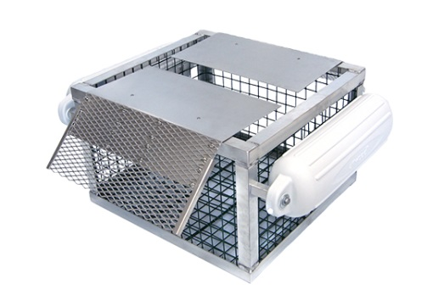
Artificial Plant Structures
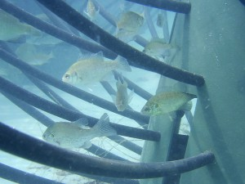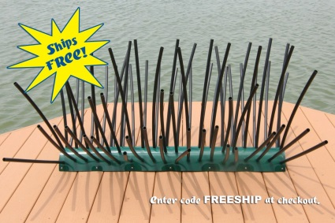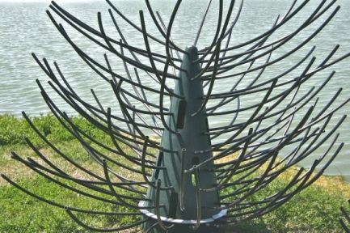

Zebco casting reels
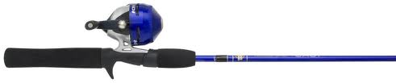
Floating Islands
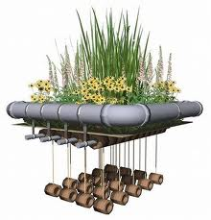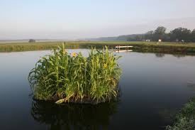

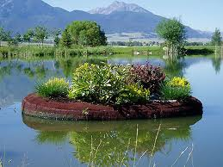
WHO WILL BENEFIT?
As you can see, there are a lot of opportunities for students all over the district to get involved in our annual population studies like fishing and tagging, turtle trapping and tagging, water quality testing, floating island launches, turtle nest tracking, and lastly frog and salamander hunting. Whenever we catch a species we will weigh it, try to determine gender and age. This means we will need to build an annual digital library of the species we collect and release. Outdoor education data gathering requires lots of hands, and how big or how little, they are always welcome.
HOW MANY STUDENTS WILL BE IMPACTED?
Directly, the WNHS ecology, zoology, AP biology, and AP environmental science students will benefit. With the common core standards changing what is taught in science across the district, I am hoping teachers will look to our projects to concretely apply concepts that would otherwise be shown in a power point. Therefore, indirectly Heritage and Robert Frost students would benefit by being within a quick walk out to the land lab. Finally, I would look for help from others like Kenny Lee in our district to get the word out about coming to the land lab facility for specific wants and needs from other schools and willing teachers in the district. This is a fabulous opportunity for all, so I can say that thousands could potentially benefit.
ITEMIZED BREAKDOWN OF EXPENDITURES:
40 fishing poles= $600
4 floating turtle traps=$916
9 Artificial Fish Shelter Structures=$1,037
12 Spawning Discs= $239
20 bags of Sand= $73.80
20 bags of 0.5 cu. Ft. river pebbles= $90
100 ft. of 3 in. PVC pipe= $110.47
16 – 3 in. 90 degree elbow connectors= $38.24
3 tubes non-toxic silicon aquarium sealer= $15
80 lb. bag Quick-crete cement= $4
Pond plants and shrubs = Approx. $400
Total = $3,523.51
OUTSIDE PARTICIPANTS and QUALIFICATIONS:
Doug Wynn, a longtime division of wildlife herpetologist, will oversee the Fall capturing, tagging, and aging of the turtles. AP biology teacher Brooke Cochran has already teamed up with a professor at Otterbein University for a similar study. Her input will be invaluable. Lyndsey Manzo of COSEE Great Lakes will apply her knowledge of water quality and aquatic habitat to water testing and the placement of artificial pond structures. I am hoping that the person in charge of the fishing club at Walnut Springs will bring the club over to our biannual Fall and Spring fishing tournament, so we can recapture some of our tagged fish. It would also be a wonderful opportunity for his club members to show elementary and high school students how to fish for bass with artificial lures.
IMPORTANT DATES:
Fall 2013
August / September / October – Water testing baseline numbers, fish population study, Fall turtle trapping and tagging, frog and salamander species identification and population quantification. Build floating islands and launch them into pond. Add artificial structures for game fish. Do a late Fall water quality test to observe harmful chemical decrease.
SPRING 2014
Do third round of water testing, spread sand and gravel on pond bottom, place spawning discs around pond, do any maintenance and replacement plants on floating islands. During the Spring fishing tournament we will record the number of recaptured fish again. Turtles will be trapped again and tagged if not previously in the fall. This will give us a good understanding of the numbers and species of turtles inhabiting the pond. The Fall of 2014, 2015, and future Falls will be pivotal times for doing proper population studies of fish due to them mating in late Spring. Springtime will also be key for identifying turtle nesting locations
REPORTING RESULTS:
Results will be reported in both Spring and Fall with words and pictures. We will include numbers of total students coming out to participate, anticipating the numbers will grow as our studies are publicized by Lynne Maslowski and other means, like word of mouth. The Westerville Education Challenge can hopefully publicize positive results from our projects and ongoing studies as well, to further exemplify to others model projects that involve many Westerville students.
OTHER FUNDING SOURCES:
In the future, we could apply for grants to the Westerville Education Foundation, or use the WNHS basil fund for upkeep and maintenance. All we need is start- up funding, and we will take care of the rest. At this time, we are not applying to other sources.
ONGOING PROJECT:
As you can by now expect, the answer is yes. With this equipment from this proposal we can have these studies going on for 10 or more years. Hopefully, more and more schools will be involved at our land lab.

Submitted by: Kyle Campbell WNHS ecology and zoology 614-282-9271

